**Experimental Graph:**

**O.C. Voltage (volts) and S.C. Armature Current versus**

**Field Current (amps) Graph**

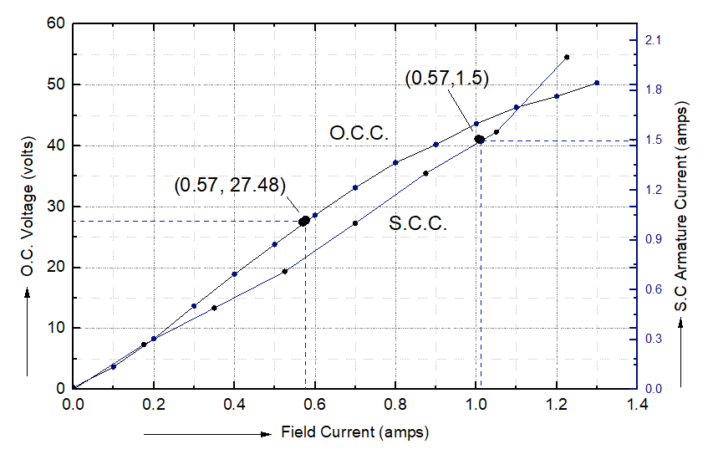

**Figure 01:** O.C. Voltage (volts) and S.C. Armature Current (amps)

on a Common Field-Current (amps) Graph for three-phase Alternator

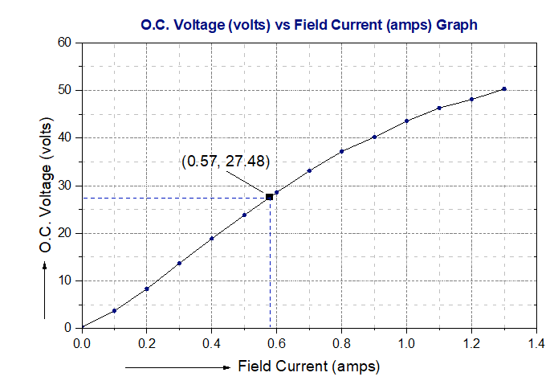**Figure 02:** O.C. Voltage (volts) versus Field-Current (amps) Graph

for three-phase Alternator.

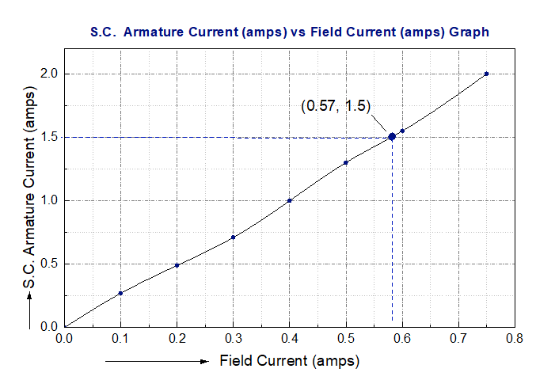

**Figure 03:** S.C. Armature Current (amps) versus Field Current (amps) Graph

for three-phase Alternator.